**Experiment No.11**

**Aim:**  Write a function which takes a tuple as a parameter and returns a new tuple as the output, where every other element of the input tuple is copied, starting from the first one.

**Program A:**

workout = {"Upper Chest": {"Bench Press": "3 sets", "Dumbell Press":"2 sets"},  
 "Lower Chest":{"Bench Press": "3 sets", "Dumbell Press":"2 sets"}}  
  
print("Way 1")  
for workout_name, workout_details in workout.items():  
 print("", workout_name)  
 print("", workout_details)  
  
print("Way 2")  
for workout_name, workout_details in workout.items():  
 print("Workout: ",workout_name)  
 print("First Variation is:\t", workout_details["Bench Press"])  
 print("Second Variation is:\t", workout_details["Dumbell Press"])

**Output:**

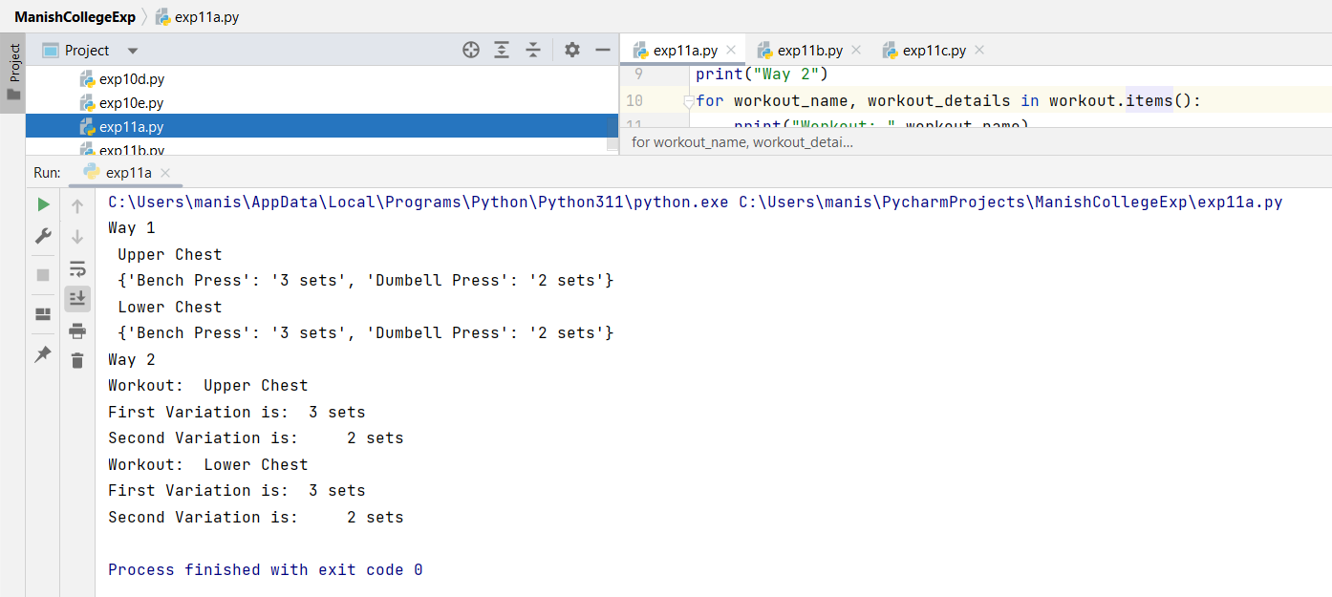

**Program B:**

def orangecap(d):  
 total = {}  
 for k in d.keys():  
 for n in d[k].keys():  
 if n in total.keys():  
 total[n] = total[n] + d[k][n]  
 else:  
 total[n] = d[k][n]  
 print('Total Run Scores By Each Player in 2 Tests: ')  
 print(total)  
  
 print('Player with Highest Score')  
 maxtotal = -1  
 for n in total.keys():  
 if total[n]>maxtotal:  
 maxname = n  
 maxtotal = total[n]  
 return (maxname, maxtotal)  
  
d=orangecap({'Test 1':{'MS Dhoni': 10,'Virat Kohli':300}, 'Test 2':{'MS Dhoni':1,'Virat Kohli':150,'Rohit Sharma':99}})  
print(d)

**Output:**

**Program C:** **Exercise:**

def how_many(animals):  
 count = 0  
 for i in animals:  
 count += len(animals[i])  
 return count  
animals = {'L':['Lion'],'D':['Donkey'],'E':['Elephant']}  
result = how_many(animals)  
print(result)

**Output:**

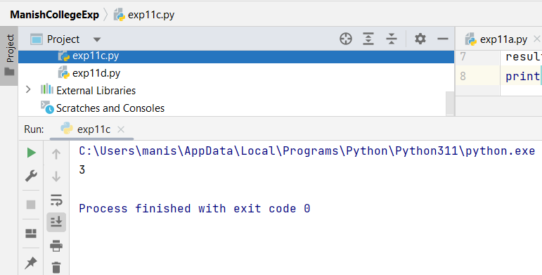

**Program D:**

def how_many(workout):  
 count = 0  
 for i in workout:  
 count += len(workout[i])  
 return count  
workout = {'Monday':['Chest'],'Tuesday':['Tricep+Leg'],'Wednesday':['Back'],'Thursday':['Bicep'],'Friday':['Shoulder'],'Saturday':['Legs']}  
print("List of Workout Split for Beginners is as follows: \n",workout)  
result = how_many(workout)  
print("Total Days of Workout Split in a week for Beginners: ",result)

**Output:**

|  |  |  |  |
| --- | --- | --- | --- |
| **Practical Performance**  **(4)** | **Writeup & Oral**  **(4)** | **Attendance**  **(2)** | **Total**  **(10)** |
|  |  |  |  |